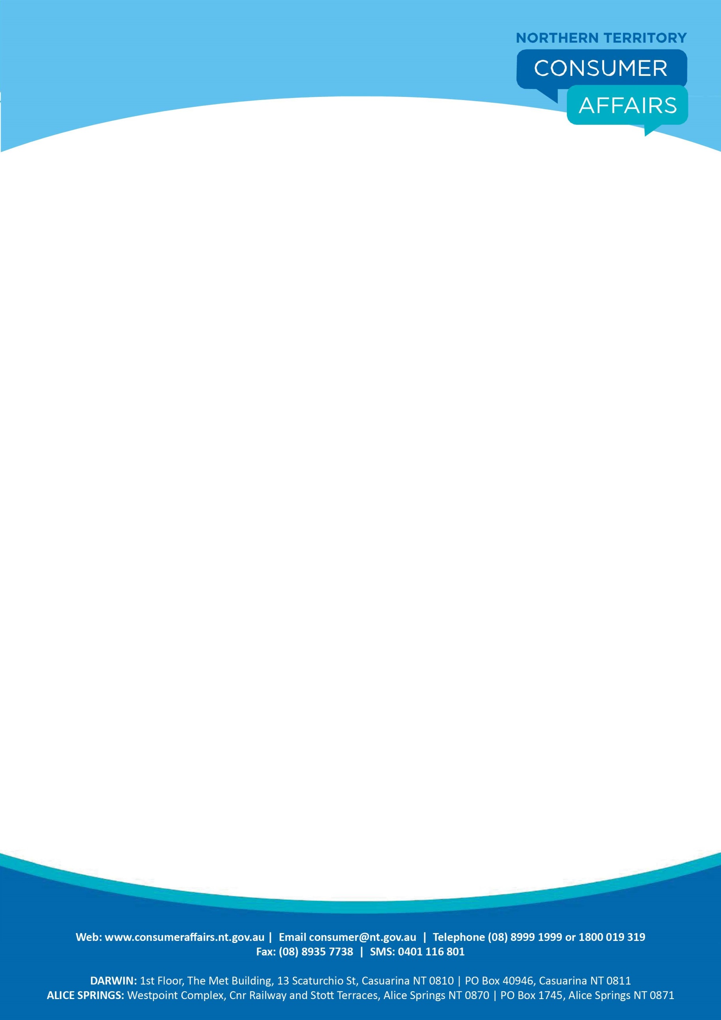

**FACTSHEET**

## MOVING OUT BEFORE A SHARED TENANCY ENDS

If you find yourself in a position where you feel that it is impossible for you to remain in a rental property as a share or joint tenant you may consider doing the following:

* Seek permission from the Landlord and other tenants to have your name removed from the Tenancy Agreement; if all parties do not agree you are still responsible under the Tenancy Agreement as it is a binding Contract.
* Find another tenant to take your place in the premises; if this is done the new tenant will take over your part of the Tenancy Agreement. In this instance the new tenant would pay the former tenant their share of security deposit and the former tenant would sign over their part of the security deposit to the new tenant.
* If you believe it is unsafe for you to remain in a rental property you may lodge an application with the Northern Territory Civil and Administrative Tribunal (NTCAT) seeking an Order to terminate your part of the Tenancy Agreement under section 99 of the *Residential Tenancies Act* under hardship. You will be required to provide evidence to NTCAT that for you to remain in the premises would cause you hardship.
* If you live in a rental property and you are not stated as a tenant on the tenancy agreement, then you are an occupant and therefore have no responsibility in relation to the Tenancy Agreement. If you are an occupant you may leave the property at any time.
* If you live a property where a tenant is already in occupation (head tenant) and you signed a new Tenancy Agreement with the head tenant, this is a sub-tenancy and the head tenant is your landlord, if you wish to leave during the term of the Tenancy Agreement refer to clauses above.

For further advice before moving out of a premises where a fixed term tenancy is in place, contact NT Consumer Affairs on 1800 019 319 or a legal practitioner at the Tenancy Advisory Service on 1800 812 953.